**Introduction to Docker** 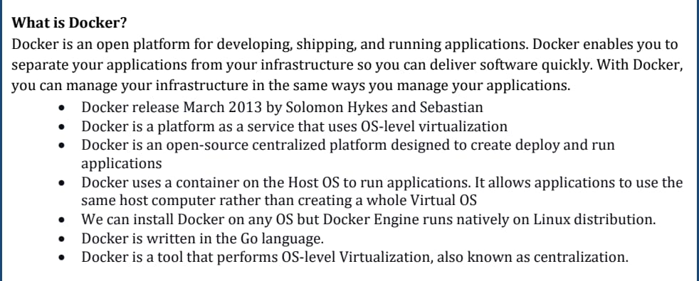

**Containerization vs. Virtualization**

* **Key Differences:**
  + Virtualization uses a hypervisor to create multiple OS instances.
  + Containerization shares the host OS, making it more efficient.
* **Benefits:**
  + Reduced resource consumption.
  + Faster application deployment and scaling.
* **Real-world Use Cases of Docker:**
  + Microservices architecture.
  + Continuous Integration/Continuous Deployment (CI/CD).
  + Cloud-native applications.
* **Lightweight Containers vs. Traditional VMs:** 
  + Containers share the host OS kernel, whereas VMs require a full OS installation.
  + No need for hypervisor overhead.
* **Less Overhead and Faster Boot-up Times:**
  + Containers start in milliseconds, while VMs take minutes.
  + Efficient resource utilization.

**Docker Architecture**

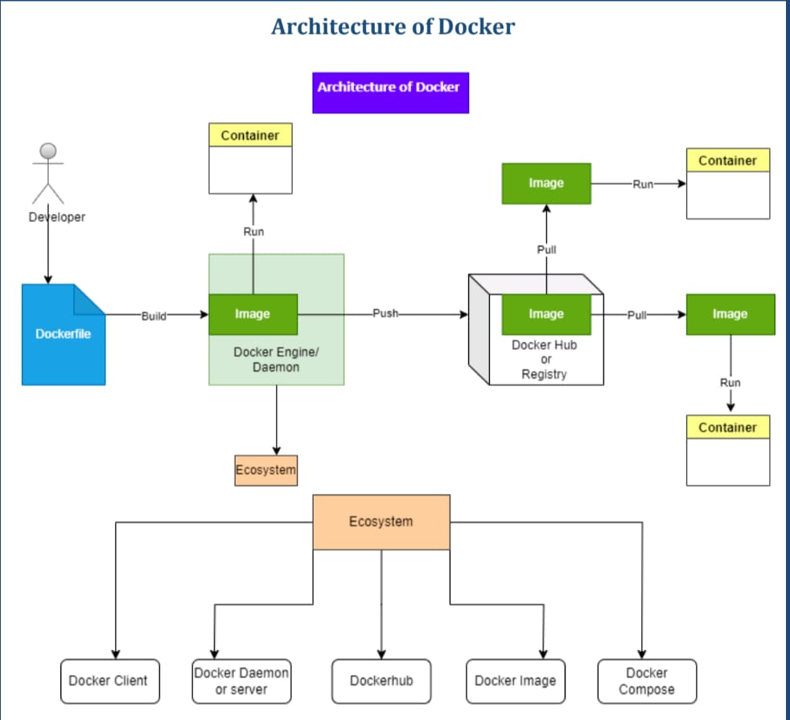

* 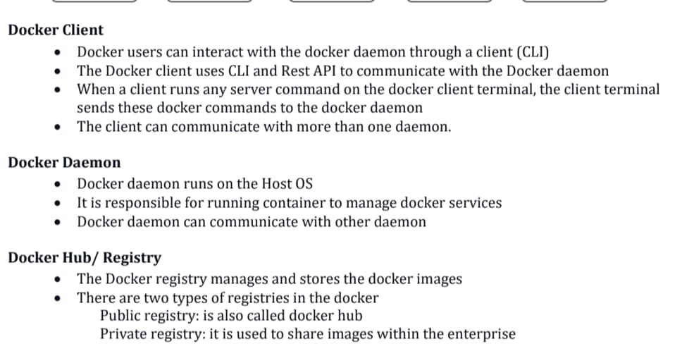**Container Lifecycle:**
  + Create, start, stop, restart, remove containers.

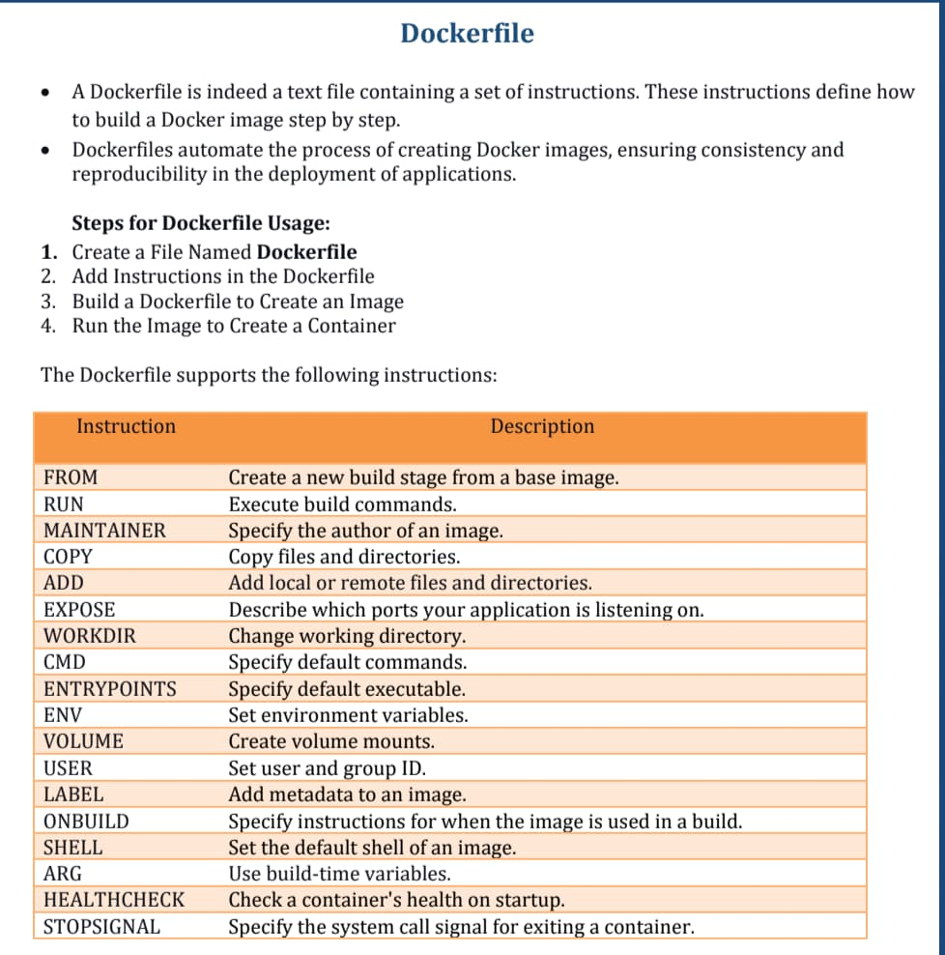

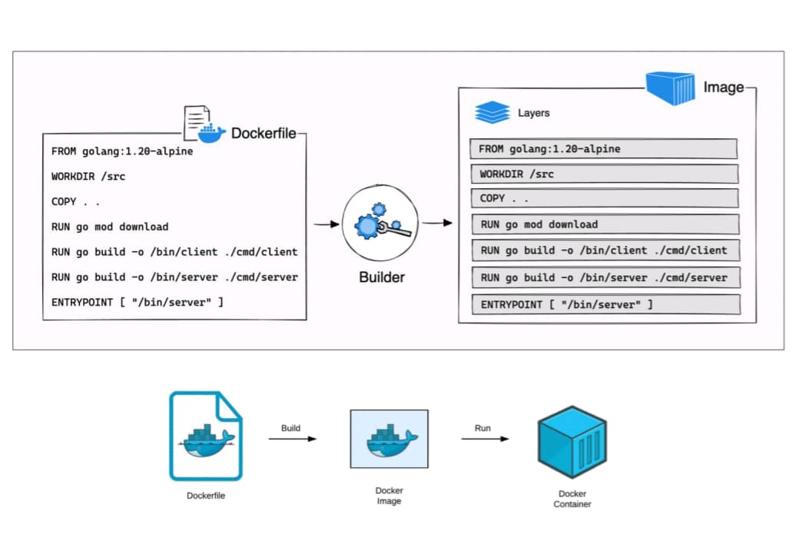

**Docker Volumes**

* **What are Docker Volumes?**
  + Persistent storage solution for containers.
* **Types of Volumes:**
  + **Bind Mounts:** Directly map a host file or directory to a container.
  + **Named Volumes:** Managed by Docker and stored in /var/lib/docker/volumes/.
* **Managing Volumes:**
  + Create a volume: docker volume create myvolume
  + List volumes: docker volume ls
  + Inspect a volume: docker volume inspect myvolume
  + Remove a volume: docker volume rm myvolume
* **Persisting Data with Volumes:**
  + Ensures data is retained even when containers are stopped or removed.
  + Useful for databases, logs, and application data.

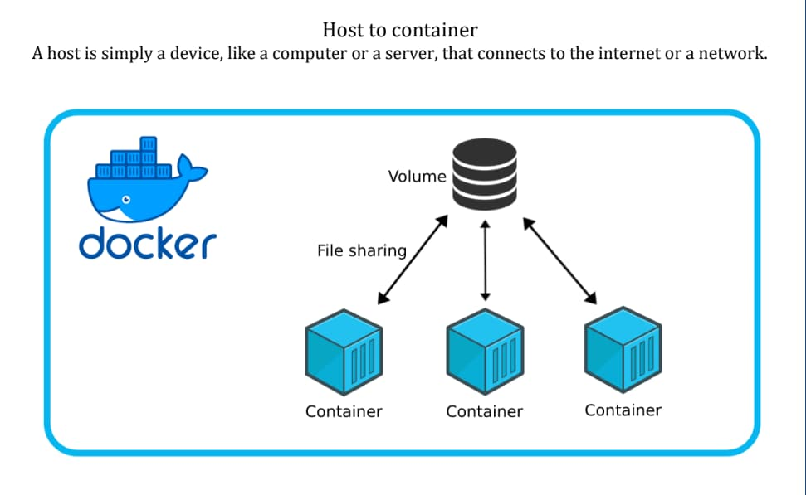

**Conclusion**

* Docker simplifies application deployment and enhances efficiency.
* Containerization is the future of software development and DevOps.
* Understanding Docker volumes is crucial for managing persistent data.